NSDD Flavor Drill May 2026

This is Document LA-UR-26-23840. Approved for public release; distribution is unlimited
Title: NSDD Flavor Drill May 2026
Authors: David J. Mercer, Jennifer Auxier, and Avilash Cramer
Date: 20 May 2026

Introduction
This is the NSDD “Flavor of the Month” drill for May 2026.
This exercise concerns sources used in the oil extraction industry. Questions 1–7 concern spectra collected with a RadSeeker detector equipped with a 3.8 cm × 3.8 cm LaBr3 scintillation crystal. Questions 8–10 concern spectra collected with a high-purity germanium (HPGe) Detective-X detector.
This exercise first appeared as a pilot drill with limited distribution in July 2020. It is reproduced here for full distribution. The estimated difficulty level is 7 out of 10.

Case A:
Consider the spectrum Case_A_Petro.N42.
This file contains three spectra:
- Spectrum 1/3: Item of Interest
- Spectrum 2/3: Na-22 stabilization source, background subtraction applied
- Spectrum 3/3: Background. Note that LaBr3-based detectors contain intrinsic radioactivity.
If your software cannot process an N42 multi-spectrum file, these spectra are available separately in the “Additional Formats” folder.
Note: If you are using InterSpec then the order of spectra within the N42 file may be different. In version 1.0.14, Spectrum 1/3 is the Na-22 stabilization source, 2/3 is the Background, and 3/3 is the Item of Interest.
To select an individual spectrum in InterSpec, click the Spectrum Files tab and use the arrows in the Foreground box to choose spectrum 1/3, 2/3, or 3/3 as shown below. You may also hide the background by clicking the “x” in the Background box.
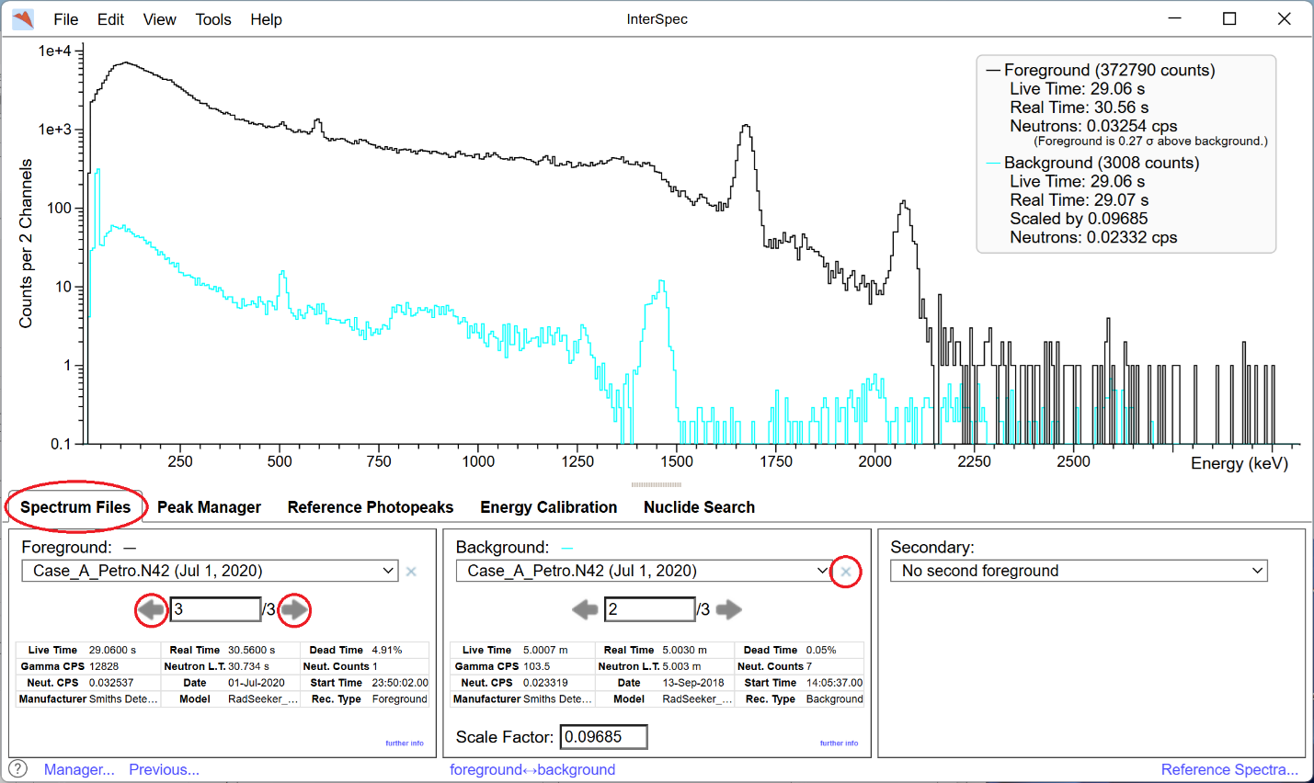

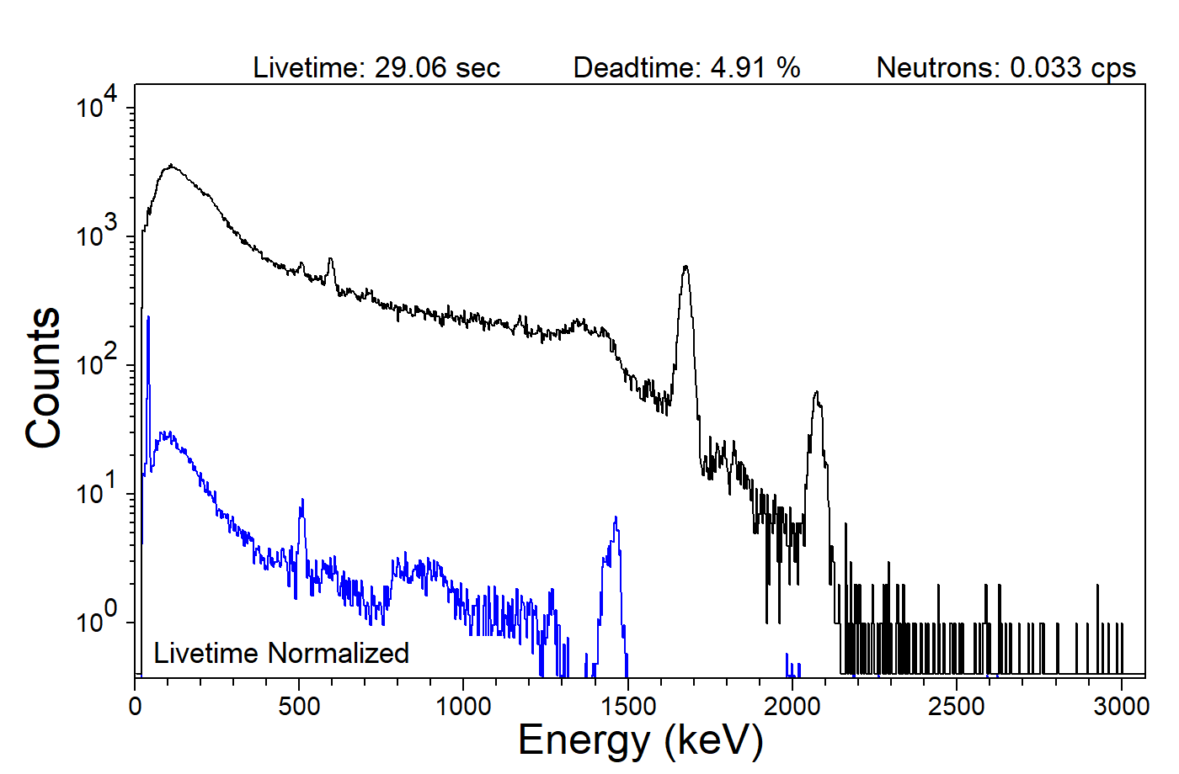
Question 1: Is a gain shift evident?
Consider the 511.0 keV positron annihilation peak in either the Na-22 spectrum or the background spectrum.
☐ Yes. A gain shift is evident.
☐ No gain shift. This peak appears at 511.0 keV as expected.

Question 2: Is the peak near 1460 keV in the background spectrum suitable for energy calibration?
Select one answer.
☐ Yes. This is the 1460.8 keV peak from K-40
☐ No. This peak contains contributions from both K-40 and La-138 in a LaBr3-based detector
☐ Yes. The K-40 and La-138 contributions can be separated in this case

Question 3: What radionuclide is present in the Case A Item of Interest?
Select one answer.
☐ As-74
☐ Ge-77m
☐ I-124
☐ Lu-169
☐ Sb-124
☐ Te-119m

Case B:
Consider the spectrum Case_B_Petro.N42.
As in before, this file contains three spectra:
- Spectrum 1/3: Item of Interest
- Spectrum 2/3: Na-22 stabilization source
- Spectrum 3/3: Background
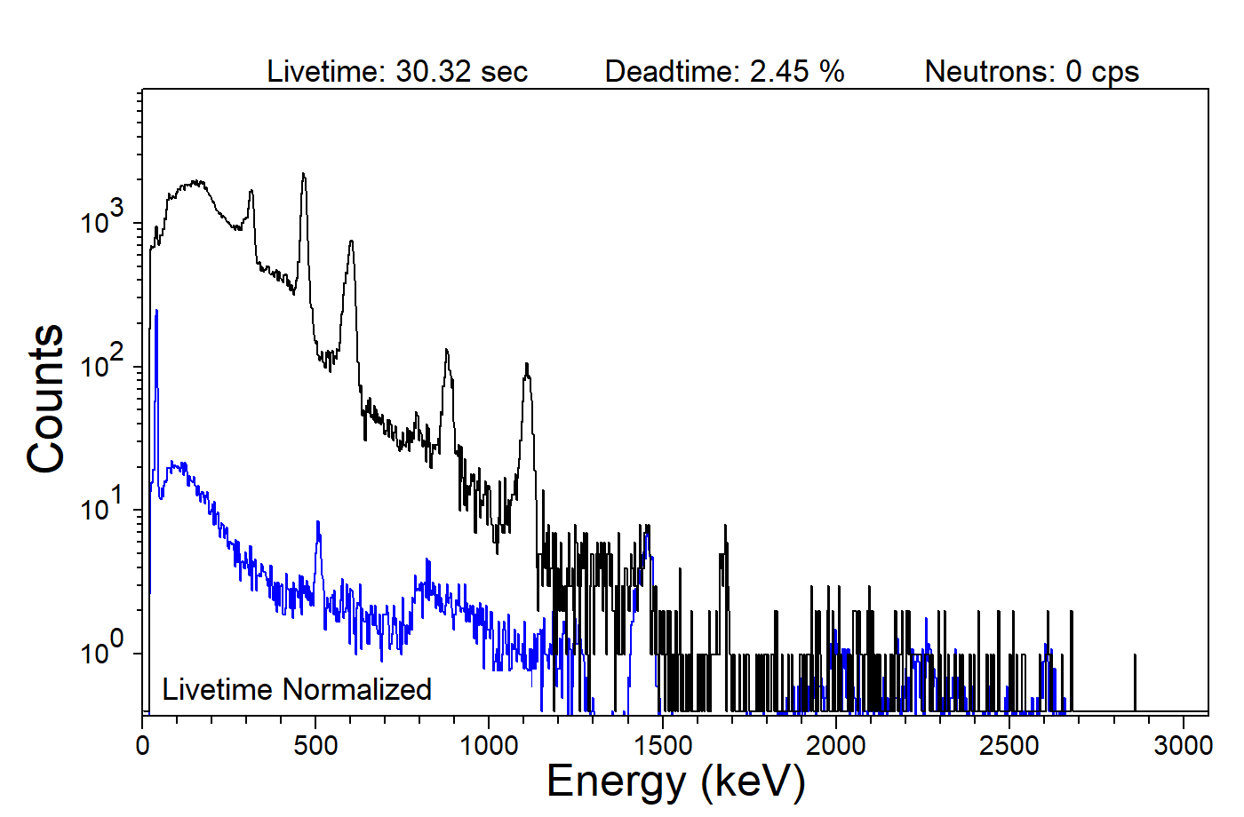
Question 4: Which two radionuclides are most prominent in the Case B Item of Interest spectrum?
Select two answers.
☐ Bi-206
☐ Ce-143
☐ Cr-48
☐ Ir-192
☐ Sc-46
☐ Te-129

Question 5: Is it plausible that the radionuclide identified in Case A is also present in Case B?
☐ Yes
☐ No

Question 6: Is there any evidence to suggest the presence of U-235, Pu-239, or Np-237 in either Case A or Case B?
Select one answer.
☐ Yes, U-235
☐ Yes, Pu-239
☐ Yes, Np-237
☐ No

Question 7: Is there evidence of shielding in either Case A or Case B?
The spectra were collected during a real cargo detection event. The shielding material and thickness are unknown.
Select one answer.
☐ Yes, distinct x-ray lines from shielding materials are visible
☐ Yes, the lower-energy peaks appear attenuated relative to the higher-energy peaks.
☐ No, I do not observe any indications of shielding.

Case C:
Consider the spectrum Case_C_Petro.SPE.
A distributed radioactive source was found near a roadway in an oil extraction region. The source is likely discarded radioactive tracer material. The spectrum was collected using a high-purity germanium (HPGe) Detective-X detector. A corresponding background spectrum, Case_C_Background.SPE, was collected nearby.
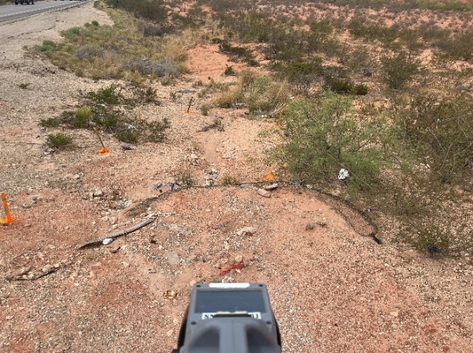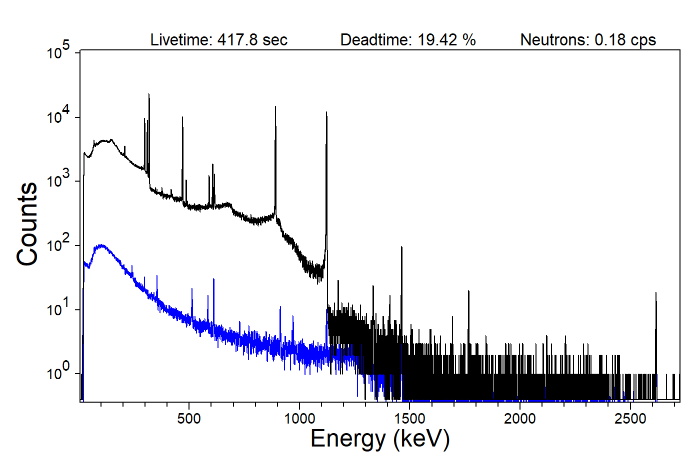

Question 8: Is the radionuclide identified in Case A also visible in Case C?
☐ Yes
☐ No
☐ Indeterminate

Question 9: Are the two radionuclides identified in Case B also visible in Case C?
Select one answer.
☐ Yes, both radionuclides are visible.
☐ Only one of the two radionuclides is visible.
☐ No, neither of the two radionuclides is visible.

Question 10: What additional radionuclide is visible in Case C?
Select one answer.
☐ Au-198
☐ Br-82
☐ Co-60
☐ H-3
☐ I-131
☐ Kr-85
☐ Na-24
☐ P-32
☐ Tc-99m

